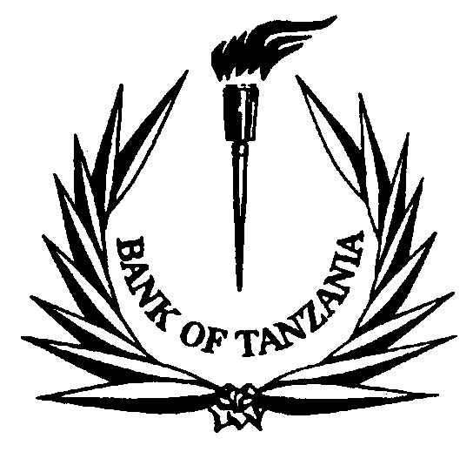

BANK OF TANZANIA

PRESS RELEASE

SURVEY ON PRIVATE SECTOR EXTERNAL DEBT

Following privatization programme and other major economic reforms undertaken by the government over the last two decades, the private sector has become more significant and more actively promoted as an engine of economic growth. Accordingly, private sector foreign borrowing has been growing commensurate to its role in economic growth. As an endeavour to have reliable external debt statistics for compilation of balance of payments and international investment position and in assessing external debt vulnerability, the Bank of Tanzania has been closely monitoring private sector indebtedness by requiring commercial banks to regularly provide information related to private sector foreign borrowing. Recently, the Bank decided to embark on regular surveys as a way to intensify monitoring and educate commercial banks, private companies and individuals on the importance of complying with the existing regulations. For that reason, from mid-September 2010 to December 2010 the Bank of Tanzania will conduct another survey and therefore request commercial banks, private companies and individuals with foreign loans to observe the following:

- To extend maximum co-operation to the Bank of Tanzania staff in responding to any questions that may be asked during the survey;

- To complete the questionnaire within one week upon receipt to enable processing the information within a reasonable time.

- To continuously report to the Bank of Tanzania the following information;

- Loan agreements (dully signed) for all loans that have not been registered and,
- All subsequent information related to disbursements, debt servicing, enhancement(s) or cancelation(s) of those foreign loans;

Collection Authority and Confidentiality

The respondents are requested to observe that the supply of the information being requested is compulsory under section 57 of the Bank of Tanzania Act, 2006. Compliance is therefore mandatory to avoid legal and/or administrative action as provided for in the Bank of Tanzania Act, 2006.

We would like to emphasize that; the collected information shall only be used strictly for statistical purposes and will only be published in aggregate form.

J. L. MASAWE

Director of Economic Research & Policy
BANK OF TANZANIA

